Common Test Roles
# Source: AI Source: Provided by: [Data Path: Persons Table -> ID Column: 1, Name_En Column: Motasem Essam] -> From: [ChatGPT] on [8/22/2025]
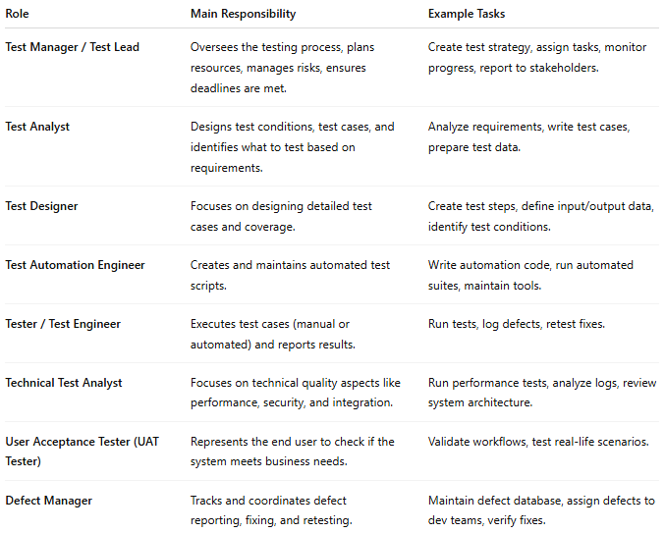
Role | Main Responsibility | Example Tasks
Test Manager / Test Lead | Oversees the testing process, plans resources, manages risks, ensures deadlines are met. | Create test strategy, assign tasks, monitor progress, report to stakeholders.
Test Analyst | Designs test conditions, test cases, and identifies what to test based on requirements. | Analyze requirements, write test cases, prepare test data.
Test Designer | Focuses on designing detailed test cases and coverage. | Create test steps, define input/output data, identify test conditions.
Test Automation Engineer | Creates and maintains automated test scripts. | Write automation code, run automated suites, maintain tools.
Tester / Test Engineer | Executes test cases (manual or automated) and reports results. | Run tests, log defects, retest fixes.
Technical Test Analyst | Focuses on technical quality aspects like performance, security, and integration. | Run performance tests, analyze logs, review system architecture.
User Acceptance Tester (UAT Tester) | Represents the end user to check if the system meets business needs. | Validate workflows, test real-life scenarios.
Defect Manager | Tracks and coordinates defect reporting, fixing, and retesting. | Maintain defect database, assign defects to dev teams, verify fixes.

